Images
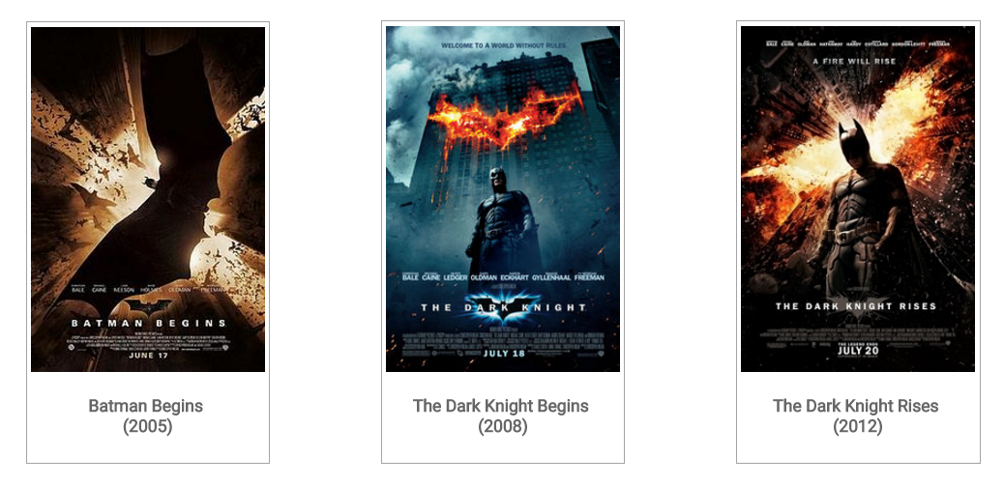
In this lesson, we will create a new section which will have list of movies on Batman. The section should look like this.

You would note, in this section, we are showing three Batman movies made by Christopher Nolan. We are using thumbnail (which is nothing but an image) along with name of the movie and the year in which the movie was released. The section also has a heading - Batman Movies. For simplicity we are using only one image. We will create a class named thumbnail for each of the movie thumbnail and define style for it.
Follow steps below to create this new section in our superhero page.
1. Create a div below Secret Identity seciton. Give identity as movie. Add h2 tag within this div
<div id=”movies”>
<h2> Batman Movies</h2>
<div>

2. Save image in the img folder. The name of the image is batman_begins.jpg Create three div for each of the movie. Assign class as thumbnail to these three divs. Insert image within this div using <img> tag
<div class="thumbnail" >
<img src="img/batman_begins.jpg" alt="Bruce Wayne">
<h4> Batman Begins <br> (2005) </h4>
</div>
<div class="thumbnail">
<img src="img/dark_knight.jpg" alt="Bruce Wayne" />
<h4> The Dark Knight Begins <br> (2008) </h4>
</div>
<div class="thumbnail">
<img src="img/dark_knight_r.jpg" alt="Bruce Wayne" >
<h4> The Dark Knight Rises <br> (2012) </h4>
</div>

3. Open stylesheet to style the thumbnail class. We will assign value to following style properties - height, display, padding margin, color, text-align,border, background-color
The CSS would look like this.
.thumbnail {
display: inline-block;
height: auto;
padding: 4px;
margin-bottom: 20px;
background-color: #fff;
border: 1px solid #a4a4a4;
text-align: center;
color: #666;
margin: 50px;
}
We have created Batman movies section. You may check the output of the file.

